Activity sheet 2.5 – Gas detective
Inquiry 1: Blowing up balloons
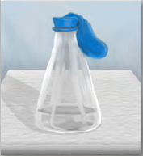
Can you blow up a balloon using vinegar and bicarbonate of soda?

Conduct the experiment
1. Place 1 teaspoon of bicarbonate of soda into a conical flask.
2. Add 25 mL of vinegar to the flask.
3. Quickly and carefully place the balloon over the neck of the flask.
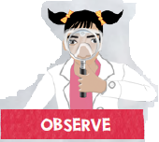
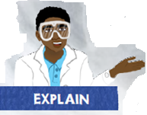

Inquiry 2: What a smell!
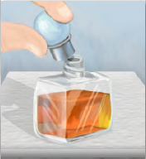
If the lid is left off a bottle of perfume two metres away from you, can you smell it?

Conduct the experiment
1. Place the perfume bottle about two metres from your seat.
2. Remove the lid and return to your seat.
3. Wait three minutes.



Inquiry 3: Bursting balloons
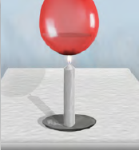
Can you heat a balloon without bursting it?

Conduct the experiment
- Inflate the balloon.
- Half fill the balloon with water and tie a knot in the end.
- Light the candle.
- Hold the balloon over the candle. Make sure the candle is under the base of the balloon.



Inquiry 4: Egg in a bottle
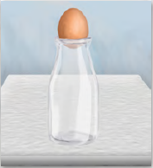
Can you get the egg inside the bottle?

Conduct the experiment
- Light the paper.
- Drop the paper in the conical flask.
- Place the hard-boiled egg on the conical flask.



Inquiry 5: Getting bigger
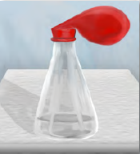
Can you change the size of a balloon?

Conduct the experiment
- Inflate the balloon to a size slightly larger than a tennis ball.
- Carefully place the balloon around the neck of the conical flask.
- Place the flask in a beaker of iced water. Record your observations.
- Place the flask in a beaker of warm water. Record your observations.



